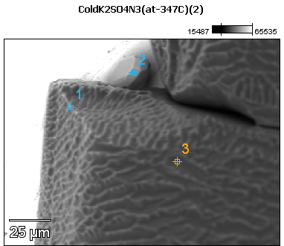

Image Name: ColdK2SO4N3(at-347C)(2)

Image Resolution: 512 by 384

Image Pixel Size: 0.33 µm

Acc. Voltage: 12.0 kV

Magnification: 750

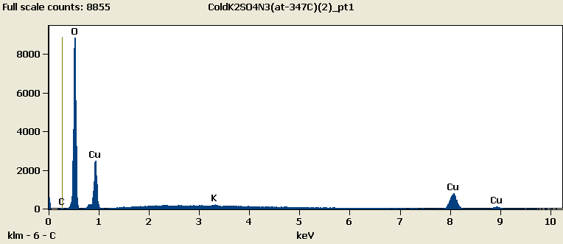

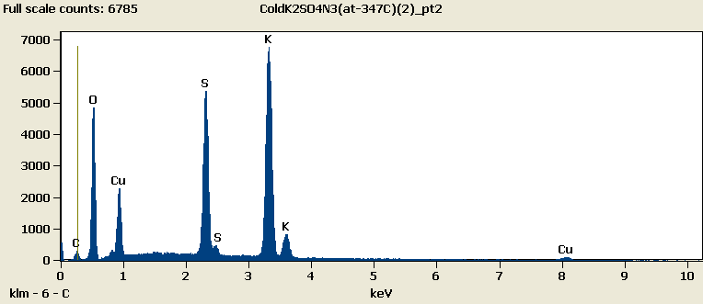

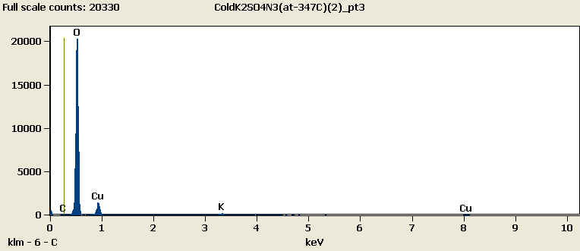

Weight %

|  |  |  |  |  |  |
| --- | --- | --- | --- | --- | --- |
|  | ***C-K*** | ***O-K*** | ***S-K*** | ***K-K*** | ***Cu-L*** |
| ***ColdK2SO4N3(at-347C)(2)_pt1*** | 0.87 | 54.86 |  | 1.07 | 43.20 |
| ***ColdK2SO4N3(at-347C)(2)_pt2*** | 2.51 | 28.01 | 17.94 | 38.05 | 13.48 |
| ***ColdK2SO4N3(at-347C)(2)_pt3*** | 0.00 | 75.90 |  | 1.73 | 22.37 |

Weight % Error (+/- 1 Sigma)

|  |  |  |  |  |  |
| --- | --- | --- | --- | --- | --- |
|  | ***C-K*** | ***O-K*** | ***S-K*** | ***K-K*** | ***Cu-L*** |
| ***ColdK2SO4N3(at-347C)(2)_pt1*** | ±0.13 | ±0.25 |  | ±0.12 | ±0.38 |
| ***ColdK2SO4N3(at-347C)(2)_pt2*** | ±0.14 | ±0.20 | ±0.12 | ±0.23 | ±0.16 |
| ***ColdK2SO4N3(at-347C)(2)_pt3*** | ±0.00 | ±0.27 |  | ±0.13 | ±0.26 |

# Cations

|  |  |  |  |  |  |
| --- | --- | --- | --- | --- | --- |
|  | ***C-K*** | ***O-K*** | ***S-K*** | ***K-K*** | ***Cu-L*** |
| ***ColdK2SO4N3(at-347C)(2)_pt1*** | 0.00 | 0.00 |  | 0.00 | 0.00 |
| ***ColdK2SO4N3(at-347C)(2)_pt2*** | 0.00 | 0.00 | 0.00 | 0.00 | 0.00 |
| ***ColdK2SO4N3(at-347C)(2)_pt3*** | 0.00 | 0.00 |  | 0.00 | 0.00 |